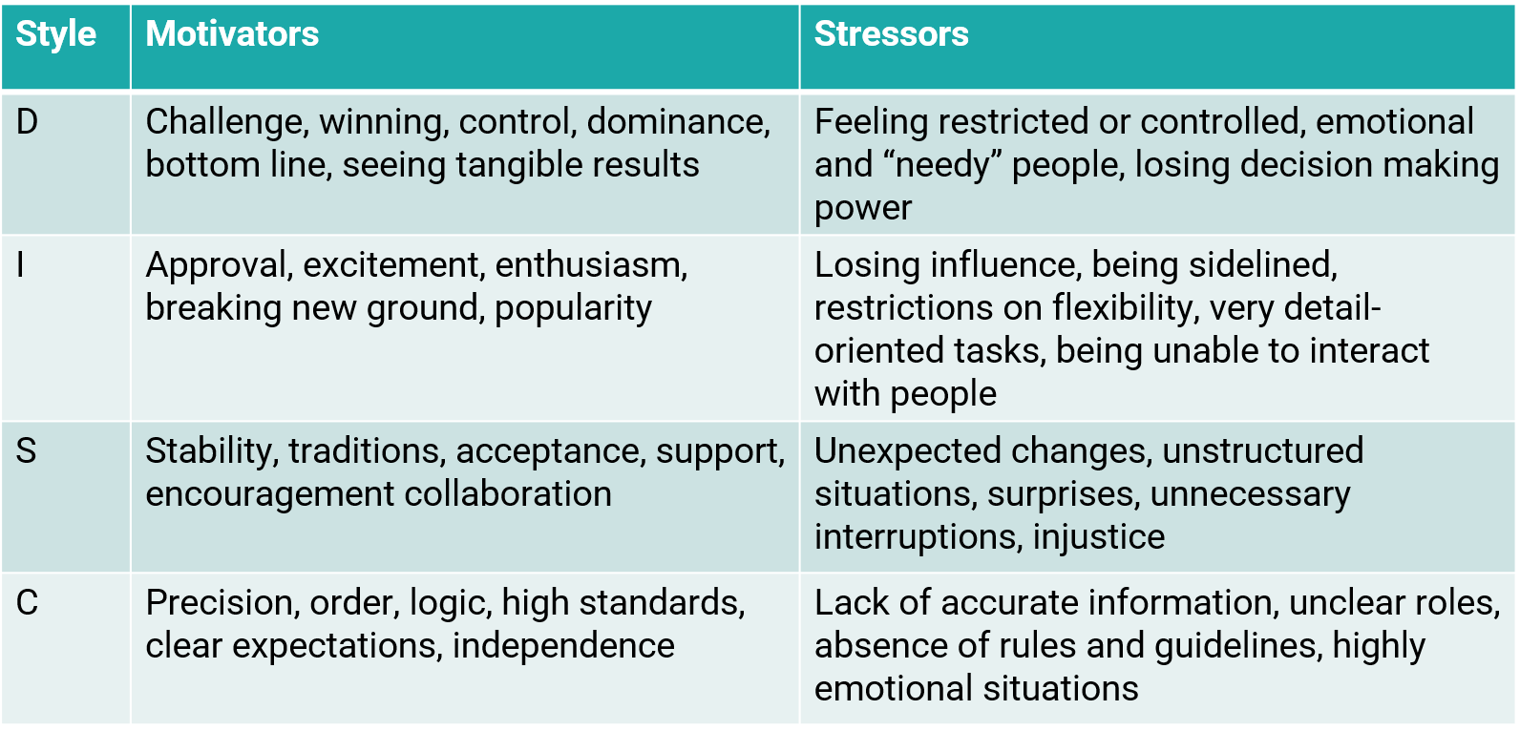
What is each DiSC style motivated by?

